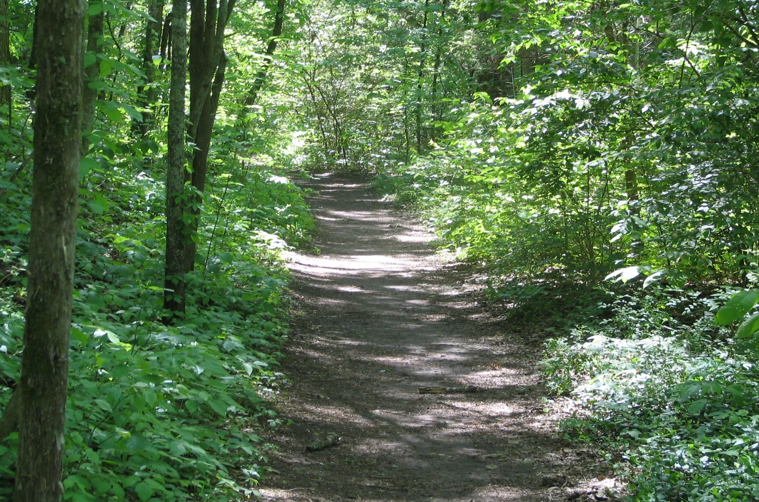

The Open Space Committee has been actively working on the construction of the County Connector Trail. The DPW has cleared the area from EverGreen Park (behind the tennis courts) to Creek Road, approximately one mile (Phase I). Phase II will include rolling and levelling the trail base. The Open Space Committee is in the process of looking into the proper surface for the trail.

With the trail under construction, please use extreme caution as the trail surface is very rough. Suggested parking is at EverGreen Park. Please be courteous to the adjoining property owners and remain on the trail. All hikers are welcome, but please no motorized vehicles on the trail.

Check back here for the official opening of the County Connector Trail!

