DEPARTMENT OF ENGINEERING AND PLANNING Division of Engineering One Spring Street Newton, New Jersey 07860 973-579-0430

2019 Sussex County Crack Sealing Program Distributed: June 14, 2019
PROJECT STARTUP NOTICE

Project:

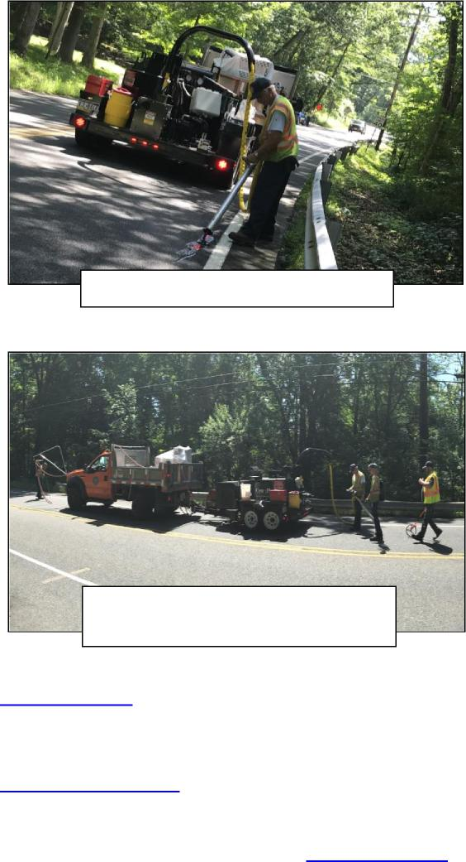
Crack Sealing Operations conducted by the County DPW personnel
Traffic Impacts: EXPECT DELAYS.
Work will be conducted under mobile single lane closures with
flagging operations.
Contact Information:
For more information about this project please feel free to contact the Sussex County Division of Public Works: 973-579-0430 or emails can be sent to dpw@sussex.nj.us
Filling cracks along County Roadways
Asphalt wearing surface Crack Sealing is a core component of the Sussex County pavement maintenance program. Crack Sealing extends the useful service life of a roadway by limiting the infiltration of water into the pavement structure. Work locations are selected based upon an evaluation of pavement conditions, traffic volumes, and in coordination with other roadway maintenance activities.
Construction Forces:
> Sussex County Division of Public Works
Project Funding:
> 100% Sussex County Capital Funds
> Miles of Road in 2019 Program: 64 +/-
Work Schedule:
Normal Work Hours: 7:00 a.m. to 3:30 p.m.
Work is scheduled to begin on or about Monday June 17th,
2019.
County Route Segments in Work Queue :
Displayed in Numeric Sequence not Order of Work
- CR 517 Newton Sparta Road
- CR 519 Branchville-Lewisburg Road
- CR 519 Libertyville- Plumbsock Road
- CR 519 Colesville – New York State Line Road
- CR 521 Mountain Road- Lake Owassa Road
- CR 560 Tuttles Corner - Dingmans Road
- CR 603 Springdale- Flat Iron Farm Road
- CR 607 Lake Lackawanna Road
- CR 608 Shotwell Road
- CR 610 Fredon- Stillwater Road
- CR 611 Kennedy/ Wolfs Corner/ Springdale Rd.
- CR 614 Paulinskill Lake Road
- CR 617 Fairview / Mt. Benevolence/ Mountain Rd.
- CR 620 Sparta Hopewell Road
- CR 622 Newton- Swartswood Road
- CR 623 Lawrence Road
- CR 630 Broad Street
- CR 639 Ross Corner/ Loomis Avenue
- CR 653 Montague Clove Road
- CR 655 County Farm Road
- CR 663 Newton- Branchville Junction Road

Division of Engineering Page 1 of 2 Public Notice: 2019 Crack Sealing Program
N:\04 Asset\01 Road\000\PAVING\Crack Sealing\2019\03 Const\10 Corr\20 Notices\05 Public Outrch\20190603_NTC_2019 SC Crack Sealing Project Startup - draft.doc

DEPARTMENT OF ENGINEERING AND PLANNING Division of Engineering One Spring Street Newton, New Jersey 07860 973-579-0430

2019 Sussex County Crack Sealing Program Distributed: June 14, 2019
Work Location Data:
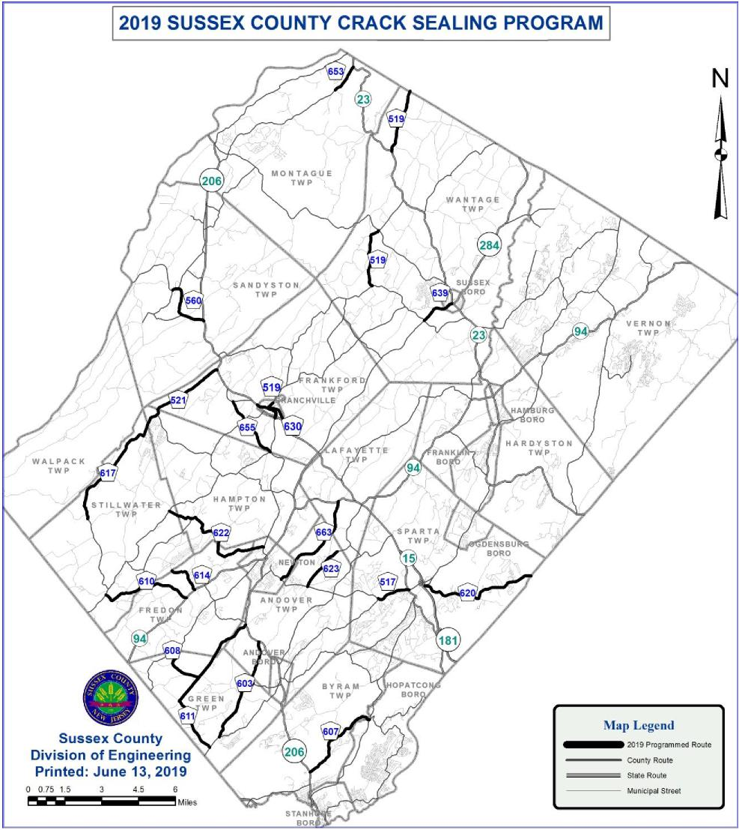
Division of Engineering Page 2 of 2 Public Notice: 2019 Crack Sealing Program
N:\04 Asset\01 Road\000\PAVING\Crack Sealing\2019\03 Const\10 Corr\20 Notices\05 Public Outrch\20190603_NTC_2019 SC Crack Sealing Project Startup - draft.doc

